

Employer Local Services Tax (LST-1) Multiple* Employer Upload
Comma-separated (.CSV) File Format

*This format must be used if you wish to file for multiple employers with a single upload file. It may also be used when filing for a single employer.

This format needs comma-separated fields.

If you are using Excel to create your file and save it in .CSV format, and your file is failing with errors, please open the .CSV file using Notepad, check the file for extraneous commas or quotation marks, and compare your records to the file format and sample valid records below.

USE COMMAS AS FIELD SEPARATORS ONLY. DO NOT USE COMMAS WITHIN A DATA FIELD. For example, do not have any embedded commas in the Employee Name or Employee Address field. Every comma is interpreted as the end of a field. Extraneous commas will cause your file to be rejected with errors that may not seem to make sense, but that actually do make sense when you take this into account.

DO NOT PLACE ANY QUOTATION MARKS IN YOUR FILE. Quotation marks shown below are for clarity of documentation only.

See Appendix B for sample records.

Zero Due EMPLOYER Filing

Each EMPLOYER record requires at least one EMPLOYEE (detail) record UNLESS the EMPLOYER record is a “zero due”. A “zero due” record is defined as an EMPLOYER record where the “Total Tax Withheld” and “Total School District Only Payments” fields are both “0.00” or “0” (columns “L” and “M” respectively from the layout defined below).

EMPLOYER / COLLECTOR INFORMATION (Header record for each employer)

There should be only one employer record per location per file, followed by the employee records for that location. If additional employers/locations exist, the employer record should follow the last employee record from the previous employer/location. See Appendix A for record sequence examples.

COLUMN NUMBER | FIELD
A | Constant value “L” – Required
B | Tax Year (2 digits, e.g. “08”) - Required
C | Tax Quarter – (last month of the quarter – “03”, “06”, “09” or “12”) – Required
D | Employer/Other Collector Federal ID (Optional, but must be nine numeric digits with no dash, if present)
E | Employer/Collector Name – Required
F | Employer/Collector Address – Required
G | Employer/Collector City – Required
H | Employer/Collector State – Required
I | Employer/Collector Zip Code. Must be in one of the following two formats: (1) Five or fewer numeric digits (for example, “8103” or “08103”), or (2) In a valid zip-plus-four format (exactly 10 characters, consisting of five numeric digits followed by a dash and four numeric digits; for example, “08103-0911”). – Required
J | Employer/Collector HAB ID - Must be no more than 7 numeric digits with no dash. – Required
K | Employer/Collector PSD code (required)  - Must be a valid Political Subdivision code as defined by the DCED.
L | Total Tax Withheld - Decimal point required if not whole dollars (1250.25); otherwise optional(1250 or 1250.00), numeric digits only– no quotes, dollar signs, commas, etc. - Required
M | Total School District Only Payments - Decimal point required if not whole dollars(1250.25); otherwise optional (1250 or 1250.00), numeric digits only – no quotes, dollar signs, commas, etc. – Required
N | Total Number of Exemptions – Numeric Value only. Enter 0 if there are none. - Required

EMPLOYEE INFORMATION (Detail records for each employer)

COLUMN NUMBER | FIELD
A | Employee Social Security Number - Numeric digits only – no dashes. Enter all zeros (“000000000”) if unknown. – Required
B | Employee Name - First name followed by last name, with no special characters (i.e., no commas, apostrophes, etc.).  Cannot be more than 100 characters. – Required
C | Employee Address – Required
D | Employee City – Required
E | Employee State – Required
F | Employee Zip Code. Must be in one of the following two formats: (1) Five or fewer numeric digits (for example, “8103” or “08103”), or (2) In a valid zip-plus-four format (exactly 10 characters, consisting of five numeric digits followed by a dash and four numeric digits; for example, “08103-0911”). – Required
G | Tax Year (2 digits, e.g. “08”) – Required
H | Tax Quarter (last month of the quarter – “03”, “06”, “09” or “12”) – Required
I | Employee Wages (Decimal point required if not whole dollars (1250.25); otherwise optional (1250) or 1250.00); minus sign allowed either before or after the amount to denote a negative amount (-1250.25; 1250.25-); numeric digits only– no quotes, dollar signs, commas, etc.)
J | Employee Amount Withheld - Decimal point required if not whole dollars(1250.25); otherwise optional(1250 or 1250.00) ; numeric digits only – no quotes, dollar signs, commas, etc.
K | Employee PSD code (Optional)  - If present, must be a valid Political Subdivision code as defined by the DCED.
L | Employee School District Only Payment - Decimal point required if not whole dollars(1250.25); otherwise optional(1250 or 1250.00) ; numeric digits only – no quotes, dollar signs, commas, etc.

Record Sequence Examples
Each example makes use of only a small number of employees and employers. Actual CSV files may contain many more employees and employers.

Example 1: Submitter with 1 Employer and 3 Employees
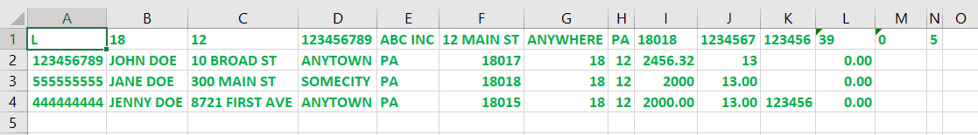

Example 2: Submitter with 3 Employers, each with a different number of Employees
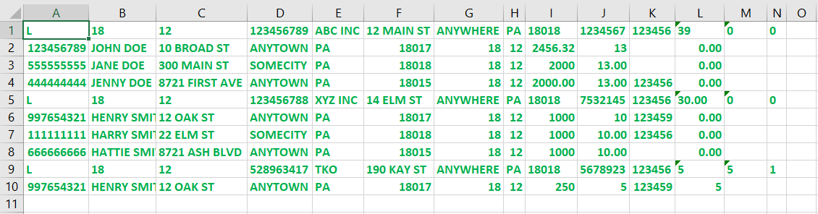

Example 3: Submitter with 1 Employer with 2 Locations, each with the same number of Employees
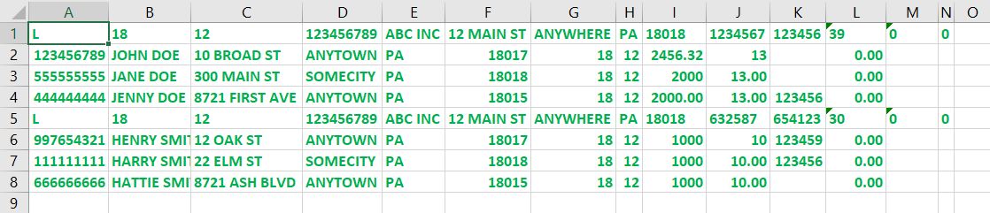

Example of file layout in EXCEL and CSV file editor such as Notepad

VALID employer information records:

Viewed in Excel:
Viewed in a CSV file editor:
L,18,12,123456789,ABC INC,12 MAIN ST,ANYWHERE,PA,18018,1234567,123456,39,0,5

VALID employee information records:

Viewed in Excel:
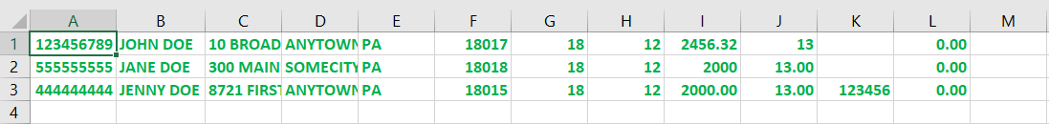

Viewed in a CSV file editor:
123456789,JOHN DOE,10 BROAD ST,ANYTOWN,PA,18017,18,12,2456.32,13, ,0.00
555555555,JANE DOE,300 MAIN ST,SOMECITY,PA,18018,18,12,2000,13.00, ,0.00
444444444,JENNY DOE,8721 FIRST AVE,ANYTOWN,PA,18015,18,12,2000.00,13.00,123456,0.00

INVALID employer information records (do not include quotes, commas or dollar signs):

Viewed in Excel:
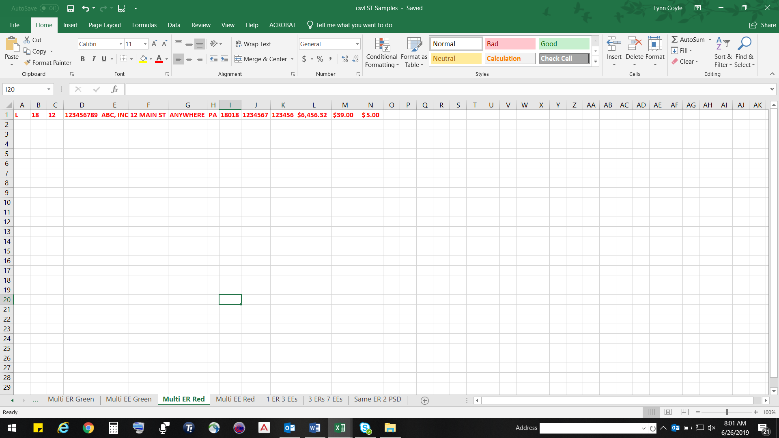

Viewed in a CSV file editor:
L,18,12,123456789,ABC,INC,12 MAIN ST,ANYWHERE,PA,18018,1234567,123456,$6,456.32,$39.00,$5.00

INVALID employee information records:

Viewed in Excel:
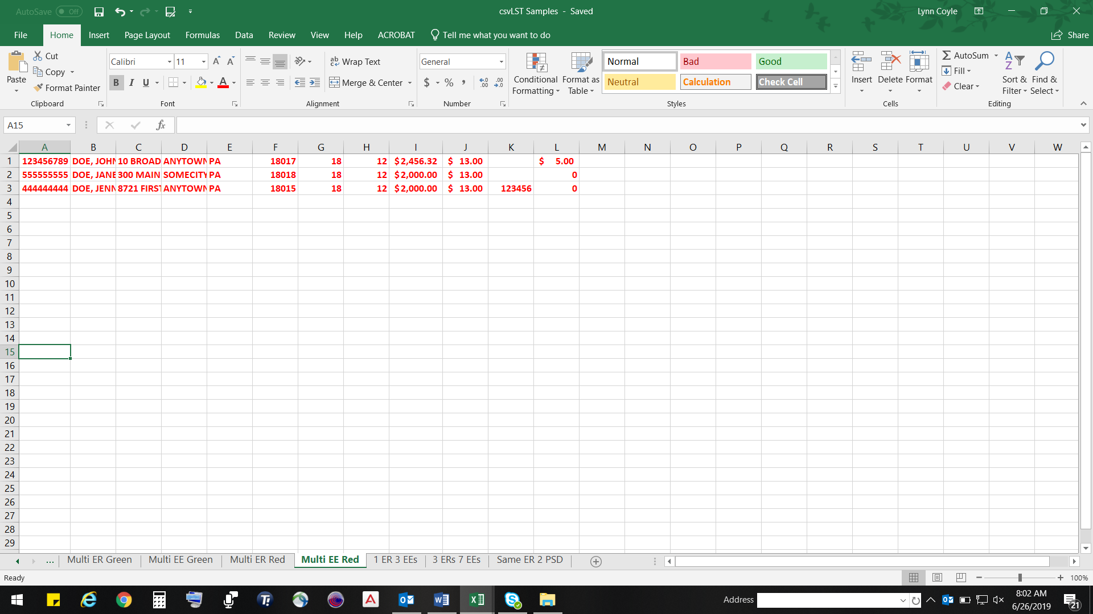

Viewed in a CSV file editor:
123456789,DOE,JOHN,10 BROAD ST,ANYWHERE,PA18017,18,12,$2,456.32,$13.00,$5.00
555555555,DOE,JANE,300 MAIN ST,SOMECITY,PA,18018,18,12,$2,000,13.00,,0
444444444,DOE,JENNY,8721 FIRST ST,ANYTOWN,PA,18015,$2,000.00,13.00,123456,0

