

Employer W2 Reconciliation Upload
Comma-separated (.CSV) File Format

This format needs comma-separated fields.

If you are using Excel to create your file and save it in .CSV format, and your file is failing with errors, please open the .CSV file using Notepad, check the file for extraneous commas or quotation marks, and compare your records to the file format and sample valid records below.

USE COMMAS AS FIELD SEPARATORS ONLY. DO NOT USE COMMAS WITHIN A DATA FIELD. For example, do not have any embedded commas in the Employee Name or Employee Address field. Every comma is interpreted as the end of a field. Extraneous commas will cause your file to be rejected with errors that may not seem to make sense, but that actually do make sense when you take this into account.

DO NOT PLACE ANY QUOTATION MARKS IN YOUR FILE. Quotation marks shown below are for clarity of documentation only.

See Appendix B for sample records.

EMPLOYER / COLLECTOR INFORMATION (Header Record for Employer)

There should only be one employer record per location per file, followed by the employee records for that location. If additional employers/locations exist, the employer record should follow the last employee record from the previous employer/location. See Appendix A for examples.

COLUMN | FIELD
A | Constant value “E”
B | Tax Year (2 digits, e.g. “08”)
C | Tax Quarter – (Constant Value “12”)
D | Employer/Other Collector Federal ID, must be nine numeric digits with no dash.
E | Employer/Collector Name
F | Employer/Collector Address
G | Employer/Collector City
H | Employer/Collector State
I | Employer/Collector Zip Code. Must be in one of the following two formats: (1) Five or fewer numeric digits (for example, “8103” or “08103”), or (2) In a valid zip-plus-four format (exactly 10 characters, consisting of five numeric digits followed by a dash and four numeric digits; for example, “08103-0911”).
J | Employer/Collector HAB ID (Optional, but must be numeric and no more than seven digits if present.)
K | Employer/Collector PSD code. (Required)  - Must be a valid Political Subdivision code as defined by the DCED.

EMPLOYEE INFORMATION (Employee Detail Records for Employer)

COLUMN | FIELD
A | Employee Social Security Number (Numeric digits only – no dashes.)
B | Employee Name
C | Employee Address – P.O. boxes not permitted
D | Employee City
E | Employee State
F | Employee Zip Code. Must be in one of the following two formats: (1) Five or fewer numeric digits (for example, “8103” or “08103”), or (2) In a valid zip-plus-four format (exactly 10 characters, consisting of five numeric digits followed by a dash and four numeric digits; for example, “08103-0911”).
G | Tax Year (2 digits, e.g. “08”)
H | Tax Quarter – (Constant Value “12”)
I | Employee Wages (Decimal point required if not whole dollars; minus sign allowed either before or after the amount to denote a negative amount; otherwise, numeric digits only – no quotes, dollar signs, commas, etc.)
J | Employee Taxes (Decimal point required if not whole dollars; minus sign allowed either before or after the amount to denote a negative amount; otherwise, numeric digits only – no quotes, dollar signs, commas, etc.)
K | Employee PSD Code (Required)  - Must be a valid Political Subdivision code as defined by the DCED.

Appendix A – Record Sequence Examples

Each example makes use of only a small number of employers and employees. Actual CSV files may contain many more employers and employees.

Example 1  Submitter with 1 Employer and 5 Employees | Example 2  Submitter with 3 Employers, each with a different number of Employees | Example 3  Submitter with 1 employer with 2 Locations, each with a different number of Employees
Employer (ACE TRUCKERS) | Employer (Best Pizza) | Employer (Johns Dogs – Lehigh)
Employee | Employee | Employee
Employee | Employee | Employee
Employee | Employer (Construction Co) | Employee
Employee | Employee | Employer(Johns Dogs – Northampton)
Employee | Employer (Ridge Rock & Gravel) | Employee
 | Employee | Employee
 | Employee
 | Employee
 | Employee

Appendix B – Sample Records

Example of file layout in EXCEL and CSV file editor such as Notepad

VALID employer/collector information records:
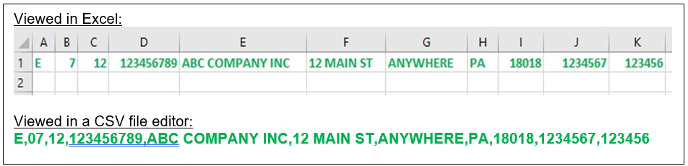

VALID employee information records:
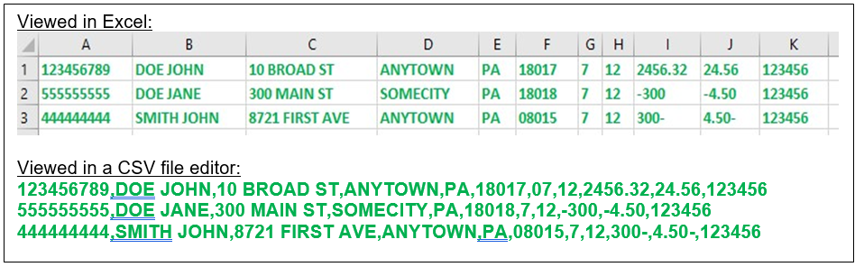

INVALID employer/collector information record (DO NOT include quotes or commas in the company name field):
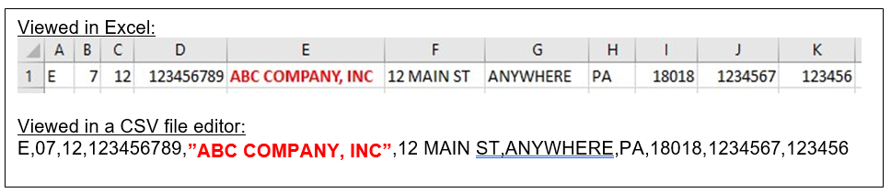

INVALID employee information record (DO NOT include quotes or commass in the employee name field):
